Title [in Times New Roman, 16 pt]

Authors’ Name (Authors’ Affiliation) [in Times New Roman, 12pt] ‡Please mark ○ in front of the presenter’s name ○Author I,¹ Author II,¹ Author III,² Author IV,² Author V¹ (Affiliation 1, Affiliation 2)
Main Text [in Times New Roman, 12pt]
This file is the template of an abstract for Poster Presentation in CSJ Chemistry Festa. In principal, please use this template for preparing the abstract. If you prepare the abstract by yourself, please refer to the following settings.
[Size] A4 portrait (297 mm in height and 210 mm in width), 1 page: [Margin] 25 mm each (top, bottom, left, and right).
Please do not fill in the box on the left of your title because your presentation number will be filled in). If you have any questions, please contact the CSJ office by e-mail (festa@chemistry.or.jp).

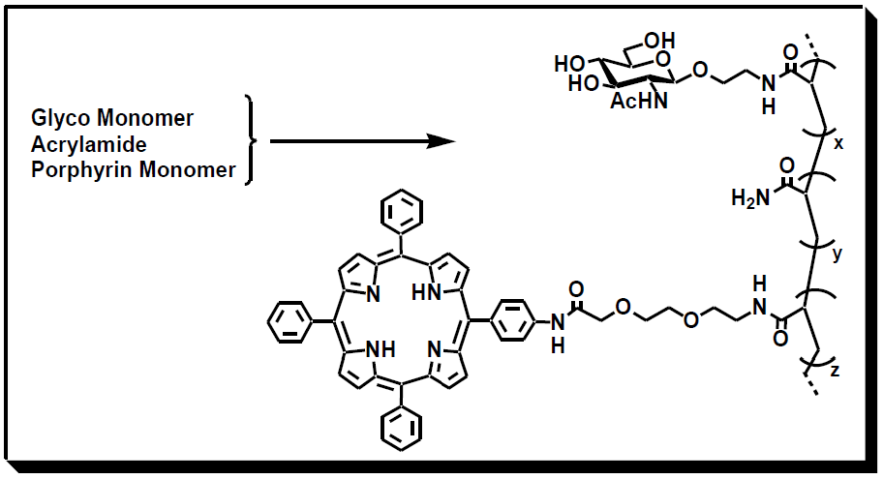
○○○○○○○○○○○○○○○○○○○○○○○○○○○○○○○○○○○○○○○○○○○○○○○○○○○○○○○○○○○○○○○○○○○○○○○○○○○○○○○○○○○○○○○○○○○○○○○○○○○○○○○○○○○○○○○○○○○○○○○○○○○○○○○○○○○○○○○○○○○○○○○○○○○○○○○○○○○○○○○○○○○○○○○○○○○○○○○○○○○○○○○○○○○○○○○○○○○○○○○○○○○○○○○○○○○○○○○○○○○○○○○○○○○○○○○○○○○○○○○○○○○○○

1）Reference 1.
2）Reference 2.

